Design thinking on vehicle parking

1. Empathize

\*Conduct user research: Interview drivers, cyclists, pedestrians, and business owners in the area.

\*Understand their pain points: How long does it take to find parking? How frustrating is it? What are safety concerns?

2. Define

\*Define the core problems based on your empathy research.

\*Focus on a specific user group and their needs.

\*Frame the problem as a human-centered question: "How might we create a parking experience that is [positive adjective] for [user group]?"

3. Ideate

\*Brainstorm solutions! Get creative and come up with as many ideas as possible.

\*Don't judge ideas at this stage; focus on quantity over quality.

\*Consider solutions that involve:

\*Technology: Smart parking apps, digital signage, sensor-based guidance systems.

\*Infrastructure: Multi-story parking garages, improved traffic flow, designated parking zones.

\*Policy & Regulation: Parking permits, time limits, pricing strategies.

4. Prototype

\*Build a low-fidelity model of your most promising ideas.

\*This could be a sketch, a cardboard cutout, or even a role-playing scenario.

\*The goal is to test your ideas with real users and get feedback.

5. Test

\*Present your prototypes to your target user group and observe their reactions.

\*Ask for feedback on usability, desirability, and effectiveness.

\*Use this feedback to refine your ideas and iterate on your prototypes.

User Requirement

1. Adequate Space: Sufficient area for parking vehicles of various sizes,

accommodating both cars and larger vehicles like trucks or vans.

2. Accessibility: Easy access to and from the parking area, with clear entrances and

exits designed to minimize congestion and facilitate smooth traffic flow.

3. Safety and Security: Measures to ensure the safety and security of parked vehicles

and their occupants, including lighting, surveillance cameras, and security personnel if

necessary.

4. Signage and Navigation: Clearly marked signage indicating parking zones,

designated spots, entrances, exits, and any relevant information such as parking fees or

time limits.

5. Compliance with Regulations: Adherence to local regulations and codes regarding

parking lot design, accessibility for disabled individuals, environmental considerations,

and any other relevant requirements.

6. Payment and Booking Options: Convenient payment methods such as cash, credit

card, mobile payments, or pre-booking options through mobile apps or online platforms.

7. Maintenance: Regular maintenance of the parking facility to ensure cleanliness,

functionality of equipment such as ticket machines or barriers, and repair of any

damages or hazards.

8. User Experience: Consideration of user experience factors such as convenience,

ease of finding parking spots, and amenities like restrooms, shelters, or charging

stations for electric vehicles.

Several problems can arise in vehicle parking, including:

1. Limited Space: In urban areas, the demand for parking often exceeds the available

space, leading to congestion, illegal parking, and frustration among drivers.

2. Inefficient Use of Space: Poorly designed parking layouts or outdated infrastructure

can result in inefficient use of available space, leading to underutilized areas or

overcrowded sections.

3. Traffic Congestion: Vehicles circling around in search of parking spots contribute to

traffic congestion, pollution, and wasted time and fuel.

4. Lack of Accessibility: Inadequate provision for accessible parking spaces for disabled

individuals can create barriers to mobility and accessibility.

5. Safety Concerns: Poorly lit or isolated parking areas may pose safety risks for

vehicles and their occupants, increasing the likelihood of theft, vandalism, or personal

harm.

6. Parking Violations: Illegal parking, such as parking in designated no-parking zones,

blocking fire hydrants, or occupying spaces reserved for specific purposes (e.g., loading

zones), can disrupt traffic flow and pose safety hazards.

7. Payment and Ticketing Issues: Outdated payment systems, confusion over parking

fees or regulations, and difficulties in obtaining or validating parking tickets can lead to

frustration and inconvenience for drivers.

8. Environmental Impact: Increased vehicle emissions from idling cars and inefficient

parking practices contribute to air pollution and environmental degradation.

The main use cases in vehicle parking include:

1. Finding Parking: Users search for available parking spots in a specific location, either

in advance or in real-time, using mobile apps, websites, or parking guidance systems.

2. Reserving Parking: Users reserve parking spots in advance, ensuring they have a

guaranteed space upon arrival, often through mobile apps or online platforms.

3. Parking Payment: Users pay for parking using various methods such as cash,

credit/debit cards, mobile payments, or digital wallets, either at parking meters, pay

stations, or through mobile apps.

4. Access Control: Users enter and exit parking facilities through access control

systems, which may include barriers, gates, ticketing machines, or license plate

recognition technology.

5. Parking Enforcement: Authorities monitor parking compliance, issue citations for

violations such as overstaying time limits or parking in restricted areas, and manage

parking enforcement processes.

6. Parking Management: Operators manage parking facilities, including space

allocation, maintenance, security, and revenue collection, to ensure efficient operation

and optimal user experience.

7. Smart Parking Solutions: Integration of technologies such as sensors, IoT devices,

data analytics, and artificial intelligence to optimize parking availability, enhance user

convenience, and improve overall parking management.

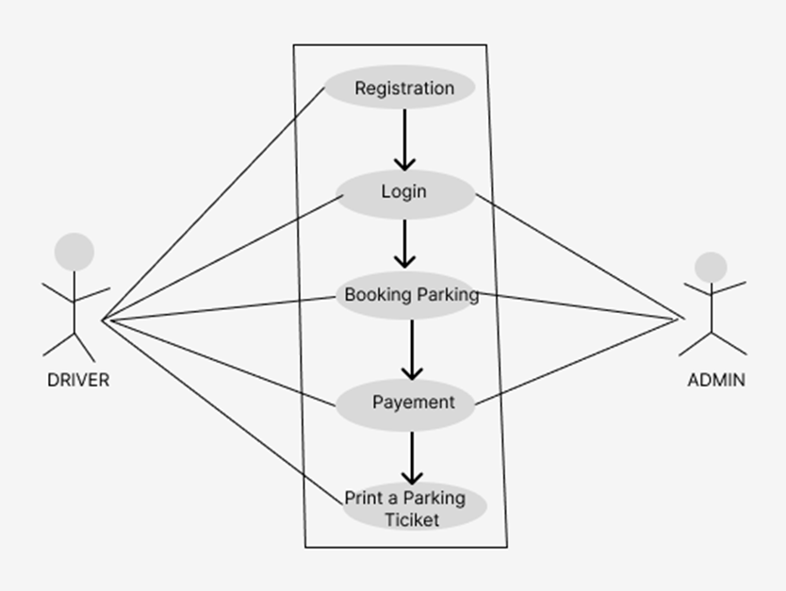

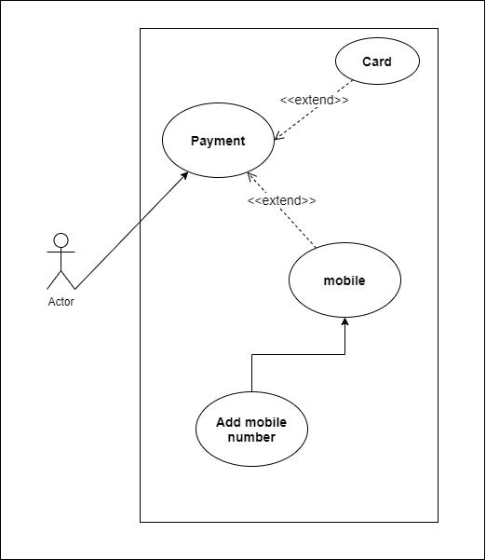

Sure, here's an example of a user story and acceptance criteria for a vehicle parking system:

User Story:

As a commuter driving to work in the city center, I want to find convenient parking quickly so that I can get to my destination on time without stress.

Acceptance Criteria:

1. Location-based Search:

- The system shall allow users to search for parking options based on their current location or a specified address.

2. Real-time Availability:

- The system shall provide real-time information on the availability of parking spaces in each designated parking area.

- The availability status should be updated frequently to reflect changes in occupancy.

3. Navigation to Parking Area:

- The system shall provide navigation directions to the selected parking area, guiding users from their current location to the chosen parking spot.

- Navigation instructions should be clear and easy to follow, utilizing maps or verbal cues.

4. Parking Reservation:

- The system shall allow users to reserve parking spaces in advance, either for immediate use or for a specified date and time in the future.

- Users should receive a confirmation of their reservation via email or SMS, including details such as location, duration, and any access codes if applicable.

5. Payment Integration:

- The system shall integrate with payment platforms to facilitate cashless transactions for parking fees.

- Users should be able to pay for parking using credit/debit cards, mobile wallets, or other accepted payment methods.

- Payment processing should be secure and encrypted to protect users' financial information.

6. Accessibility Features:

- The system shall provide information on the availability of accessible parking spaces for users with disabilities.

- Accessible parking spaces should be clearly marked and located close to entrances or elevators for ease of access.

7. Feedback Mechanism:

- The system shall allow users to provide feedback on their parking experience, including ratings and comments on factors such as cleanliness, safety, and convenience.

- Feedback should be collected anonymously and used to improve the overall quality of the parking service.

8. Emergency Assistance:

- The system shall provide emergency assistance options in case of vehicle breakdowns or other unforeseen circumstances.

- Users should be able to request assistance via the app or by contacting a designated support hotline.

9. Integration with Public Transit:

- The system shall provide information on nearby public transit options for users who prefer to combine driving with other modes of transportation.

- Integration with public transit schedules and routes should be seamless, allowing users to plan their journeys efficiently.

10. Compliance with Regulations:

- The system shall comply with all relevant regulations and standards for parking facilities, including zoning requirements, accessibility laws, and data protection regulations.

- Parking areas should be well-maintained and meet safety standards to ensure the well-being of users and their vehicles.